|  |  |  |  |  |  |  |  |  |
| --- | --- | --- | --- | --- | --- | --- | --- | --- |
|  |  | |  | **10. YOUR SOLUTION SL**    The solution is to use an AI based application system that detects the skin disease which is then recognized and convert them into test report. The AI model is trained to detect the human skin with the help of camera and then processess with the datas fed in the system. |  | | |  |
| **3. TRIGGERS** | **T R** | **8. CHANNELS of BEHAVIOUR** | **CH** |  |
| An helpful application for people who was unable wait | |  | **8.1 ONLINE**  Some users are not aware to use the application and it's process to detect skin disease is fast    **8.2 OFFLINE**  People have to wait for the doctors and also have to wait for the report about their skin it is a slow process | | |
| for doctor appointment and for people don’t have enough money to get test in hospital | |  |
| **4. EMOTIONS: BEFORE / AFTER E**    BEFORE: Peoples wait for the doctor appointment to consult the docto about their skin disease and another few hours of waiting to get their results.    AFTER: Now peoples don’t have to wait for doctor appointment they do consulting and get results quickly with this application. | | **M**  r  can |

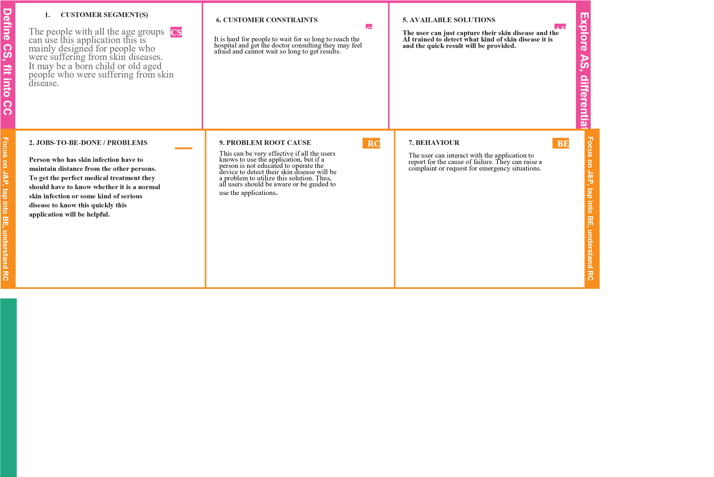**Project Title: AI-based localization and classification of skin disease with erythema Project Design Phase-I** - **Solution Fit Team ID:PNT2022TMID07637**